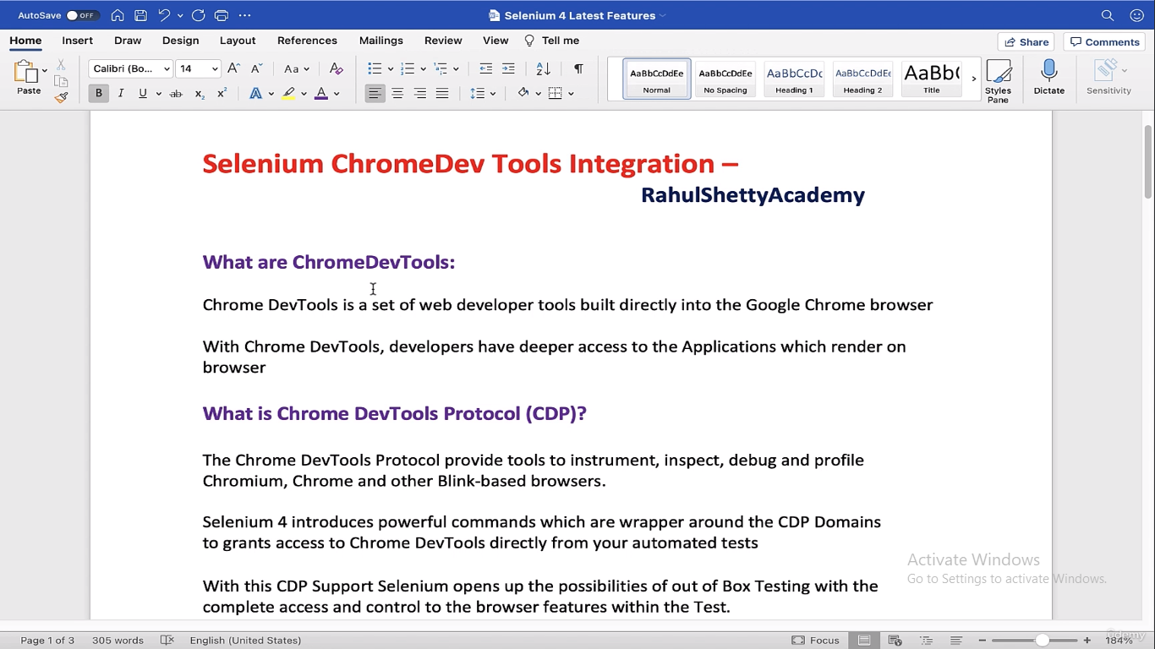

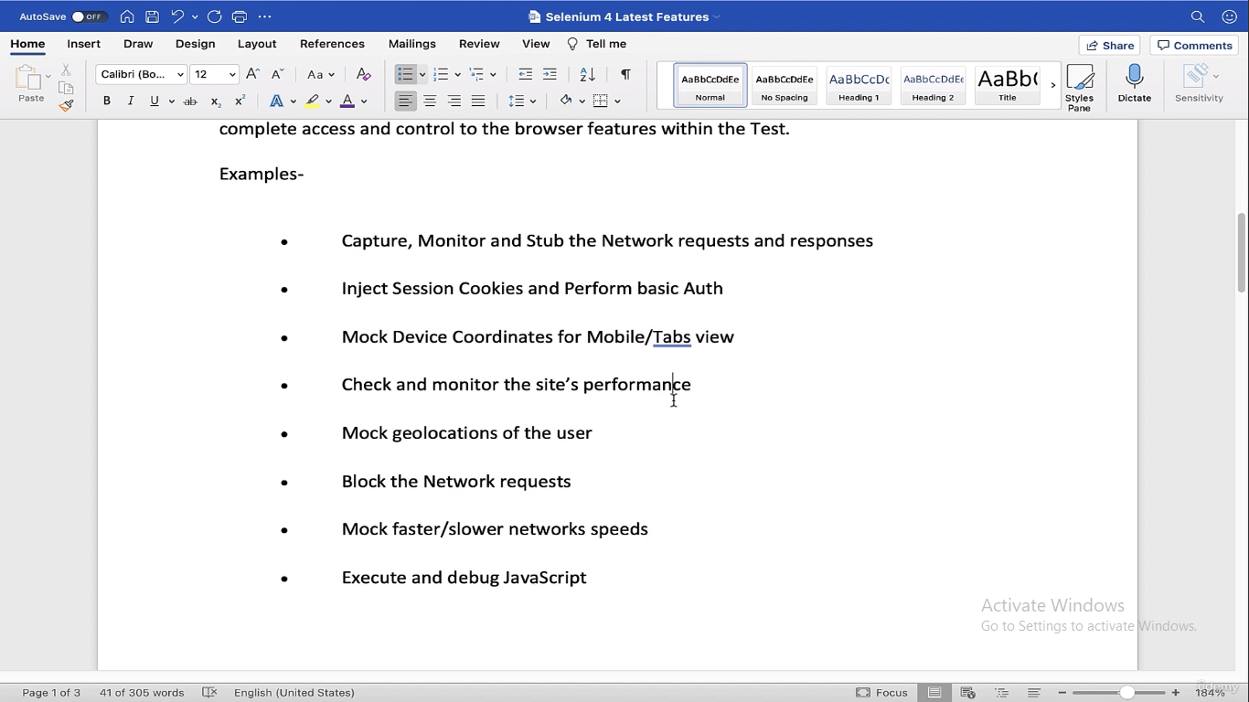

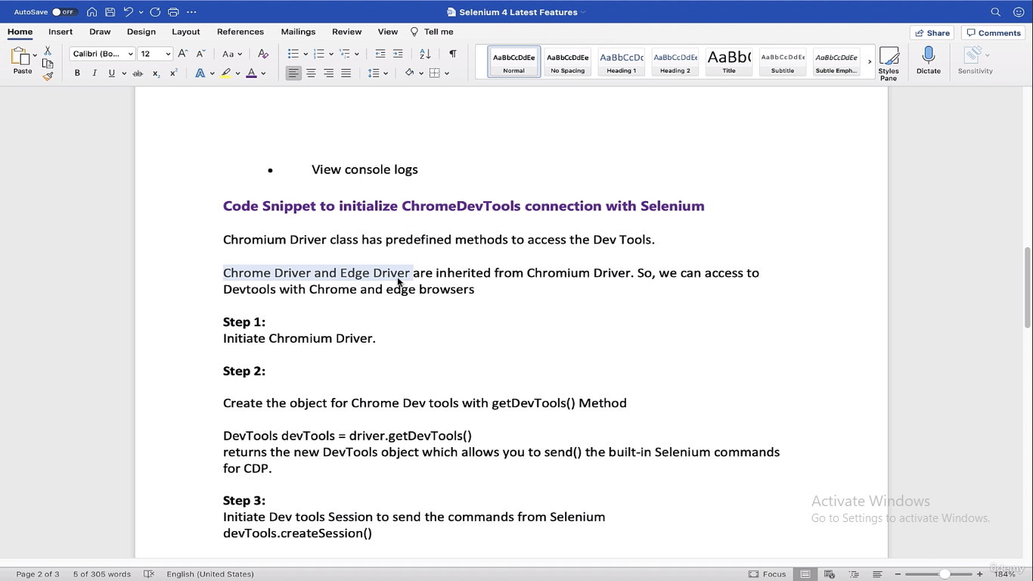

Basically ChromeDev tools protocol is for using all the options that we have on Chrome (like converting to mobile page….and all other) and handle that with selenium

-----------------------------

Below is the page where you can see all the methods that you can use for chrome dev tools. In below I’m looking Network one

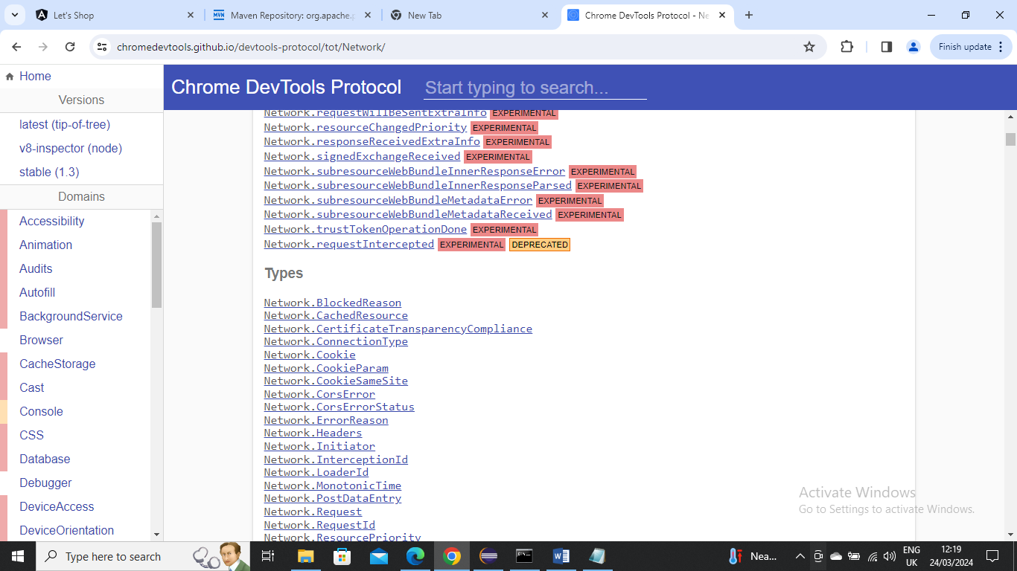

-----------------------

Below is the example where I’m using method “setDeviceMetricsOverride” to simulate browser as mobile

You can get all the paramters info like what are mandatory and what are optional and what type of value should be passed from chrome dev tools protocol page

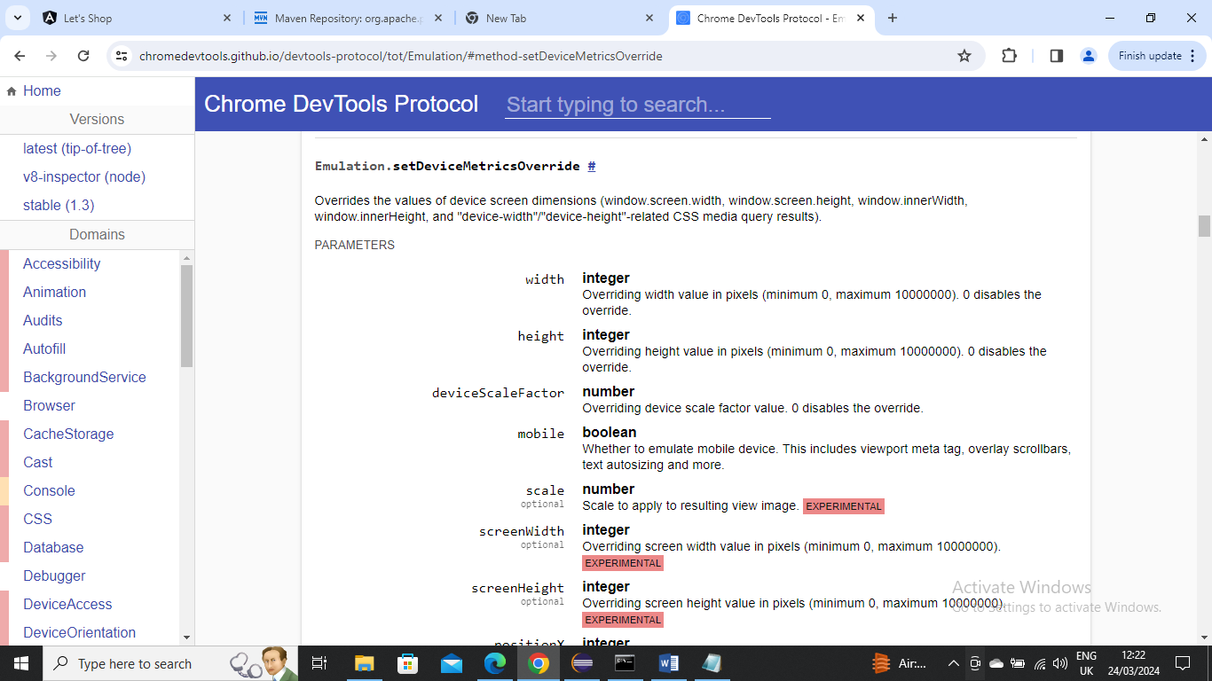

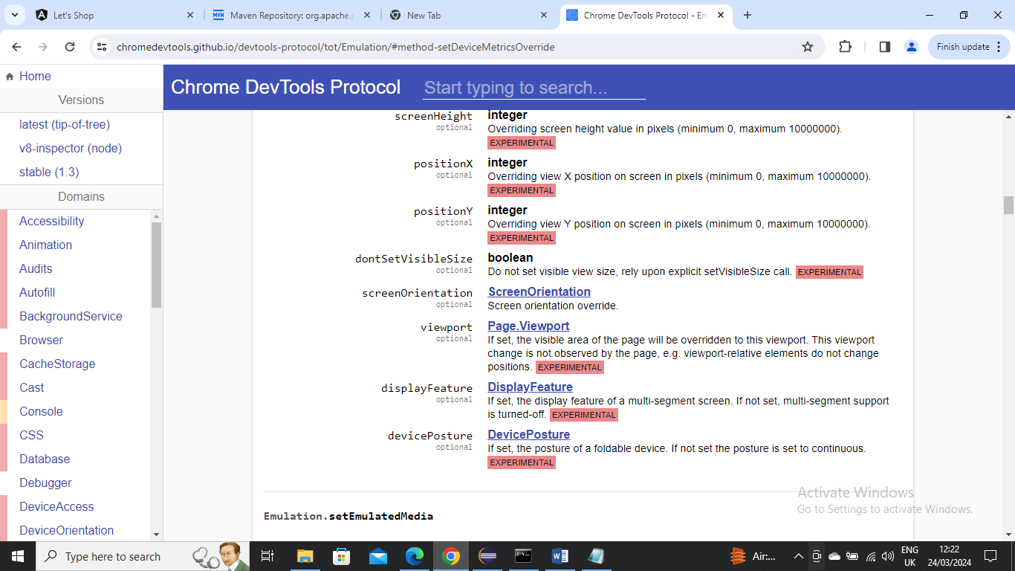

Below is the code

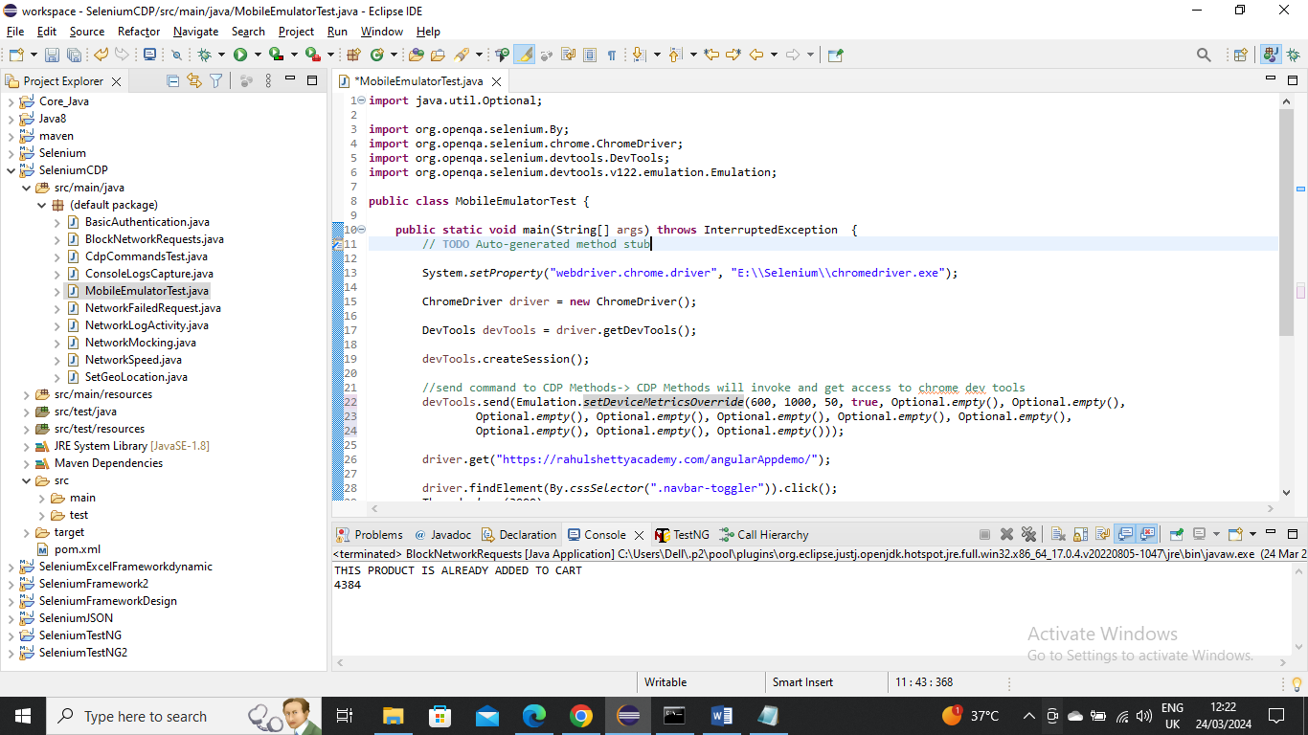

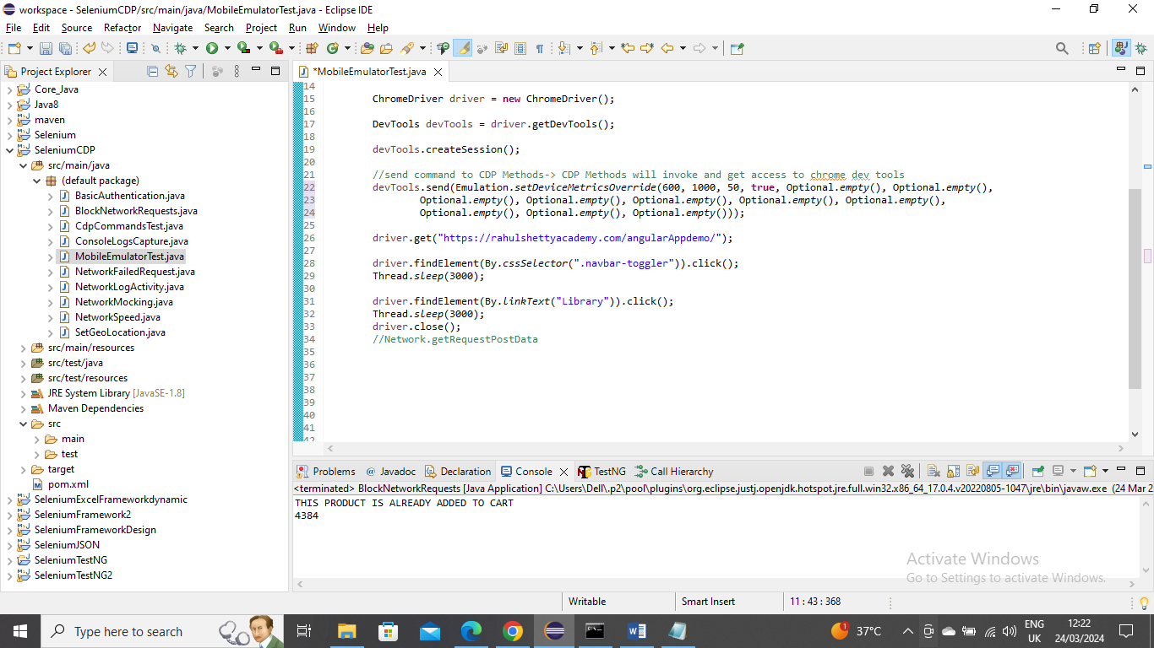

Below is the output

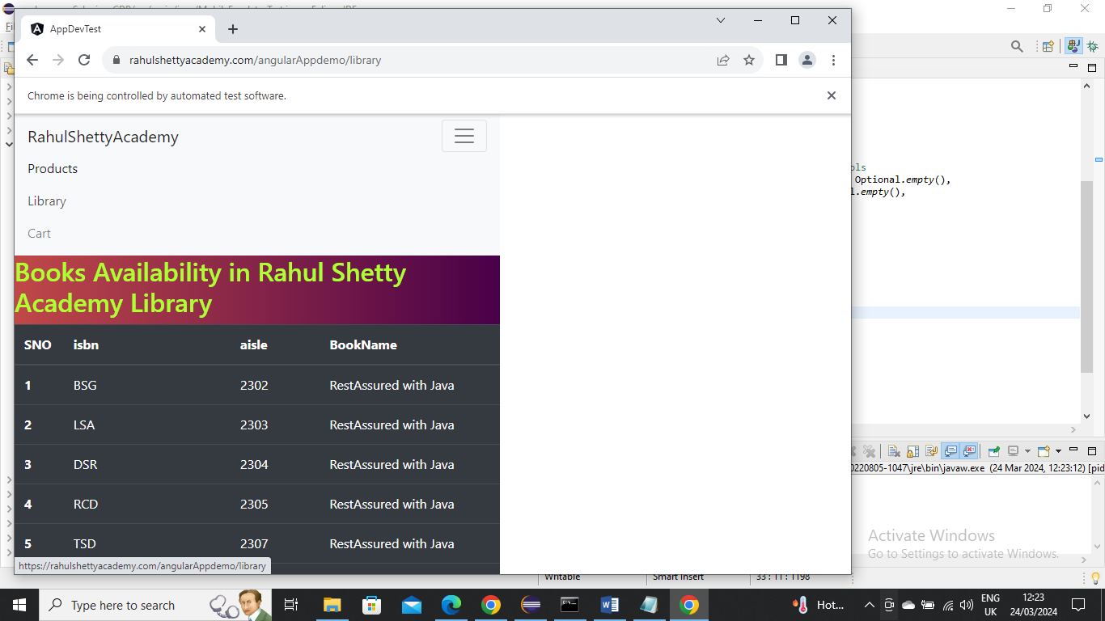

-----------------------------------------

There may be scenarios where the chrome dev tools Protocol commands are not there in that case you can build your own customer command.

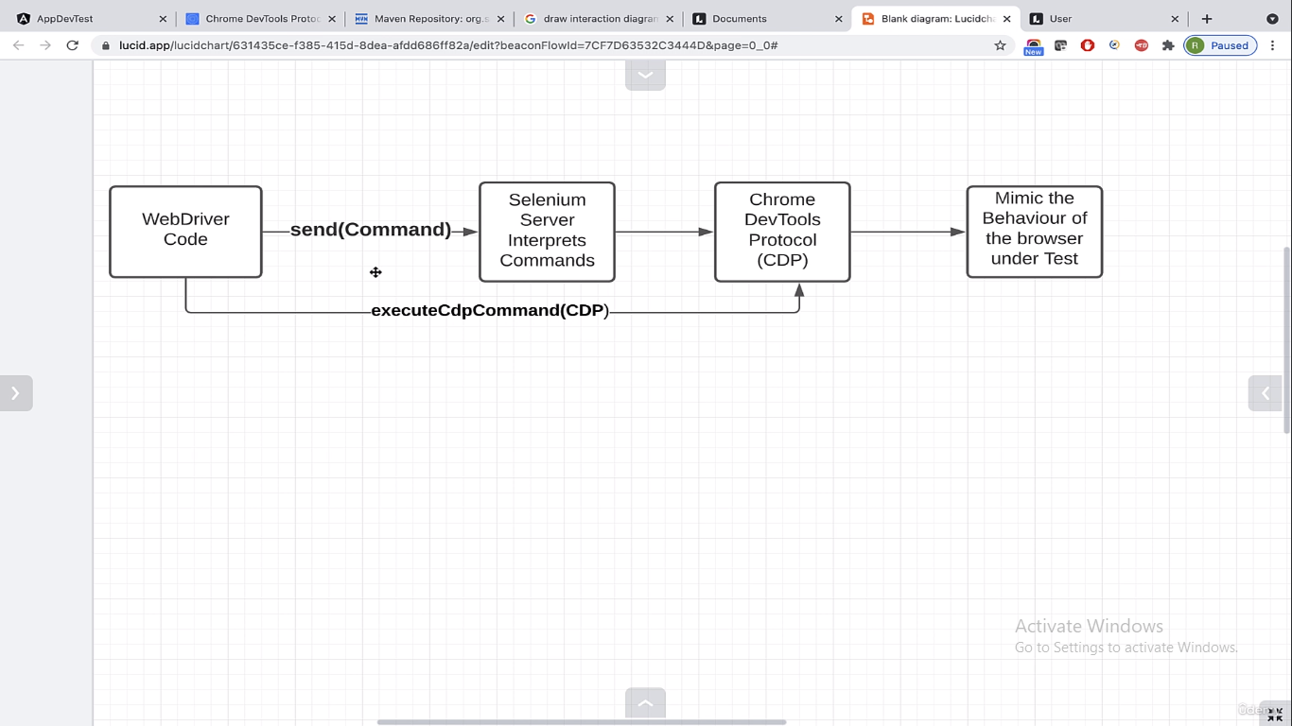

For example let’s say setDeviceMetricsOverride doesn’t exist in that case you need to build this command using method “executeCdpCommand” and create it

Below is the code where assuming we don’t have “setDeviceMetricsOverride” command and we built on our own

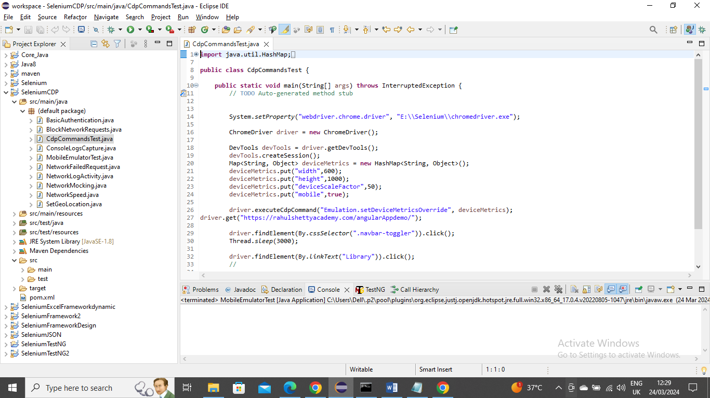

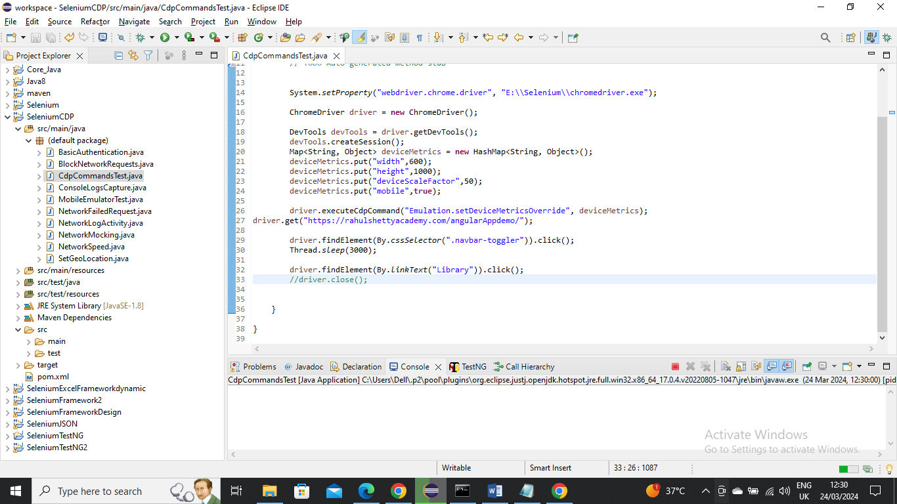

Below is the Output

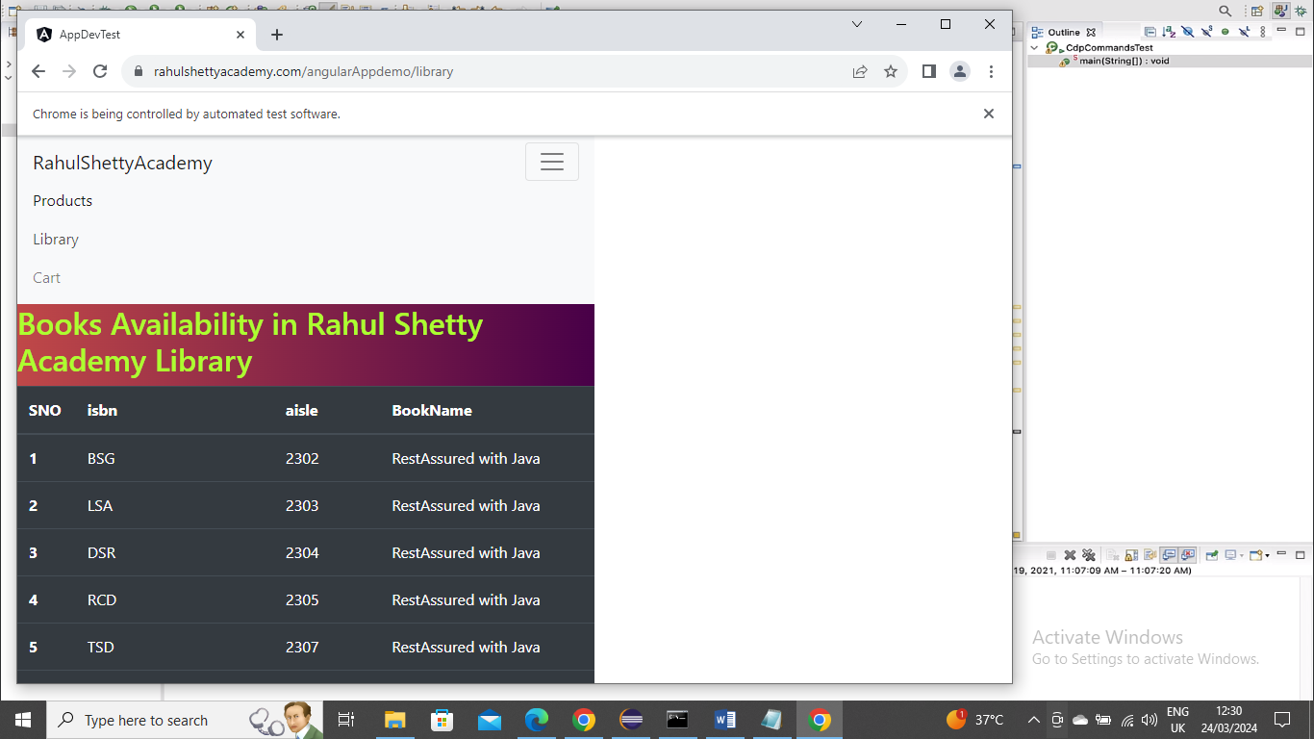

-----------------------------

Below is an example where you login to say Spanish Netflix and get the some title info …….basically we are doing localization testing where are trying to open webpage of certain location. In below I took longitude and latitude location from google maps….In below I took co-ordinates for Madrid

Also In below I did custom method and already existing method from Chrome Dev Tools Protocol

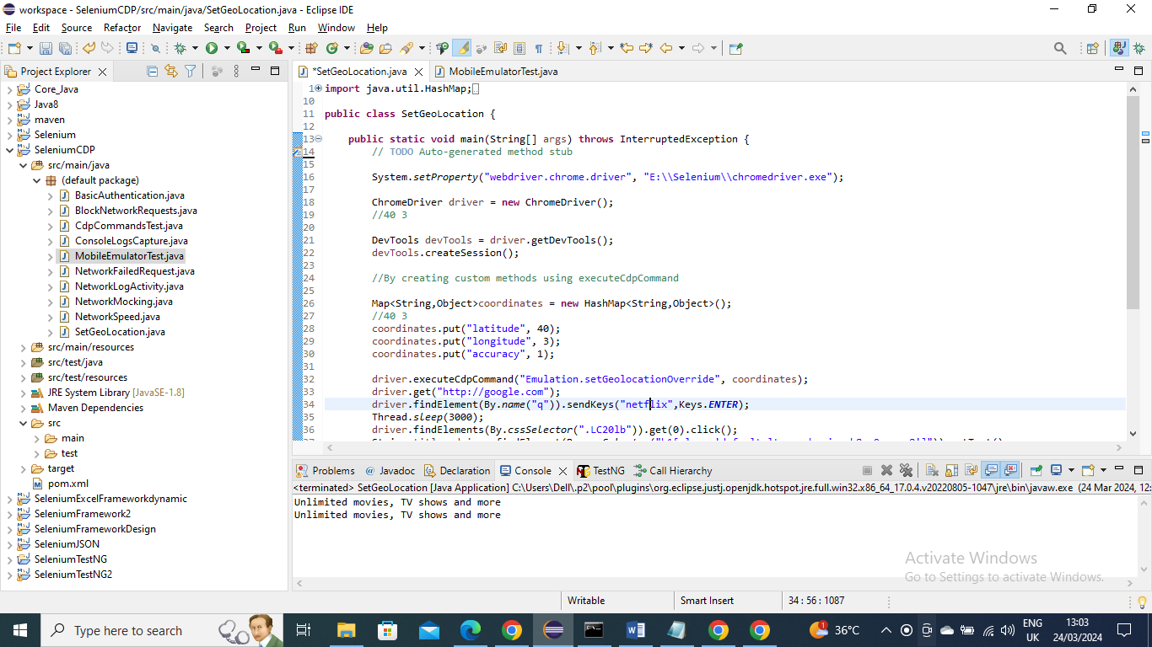

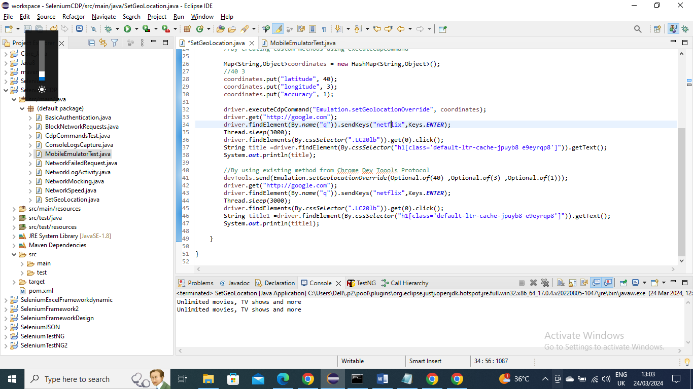

--------------------------------------

Below is an example where sometimes there may be issue with that site where response is slow or no response. We can check from Selenium whether is there is no issue with that site

As you know if below 400 the connection is good

Below is the code

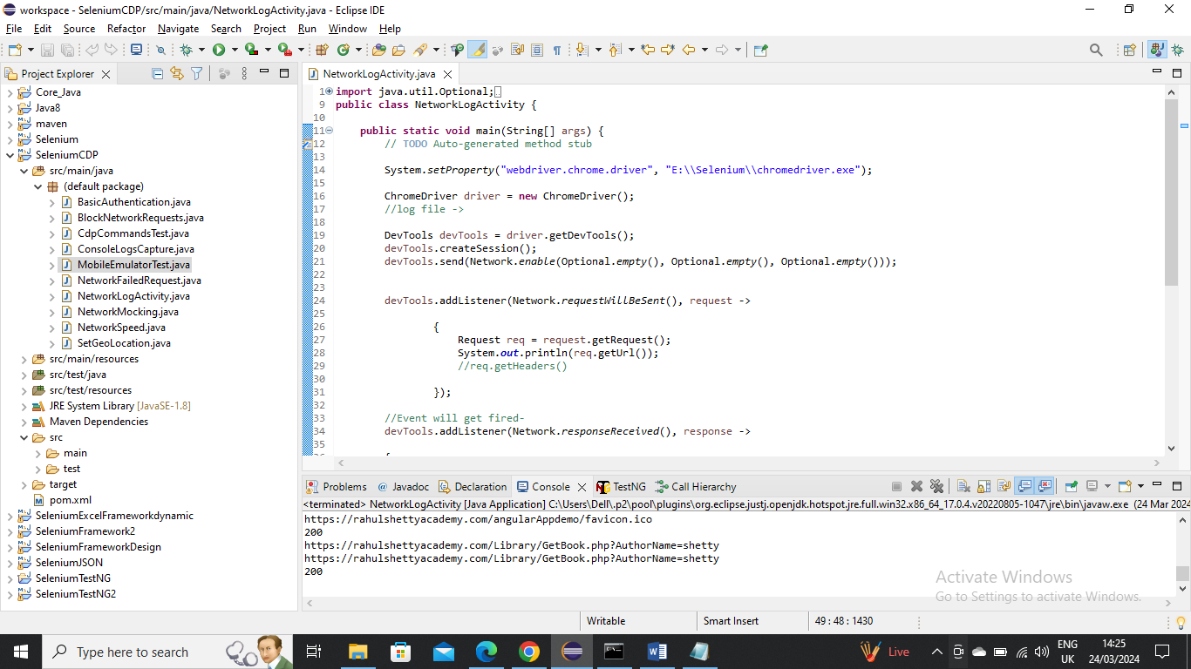

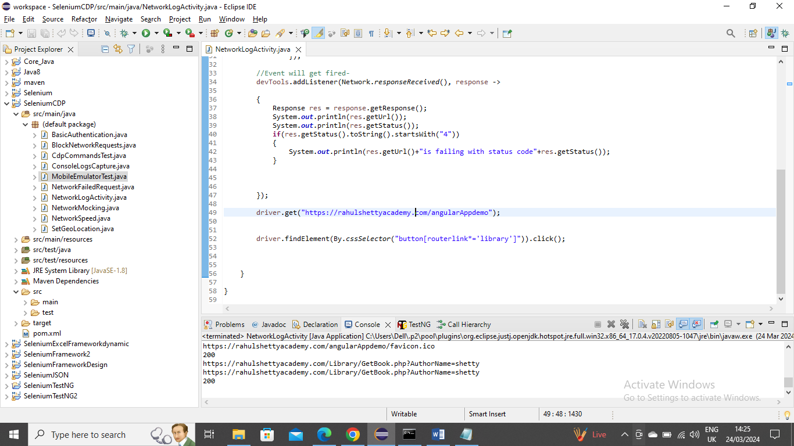

As you can see in above console the status sent and received is 200 which means its ok

----------------------------------------------

Below is an example where you want mock/tweak the request to check for 1 record

In below you want test when only 1 records is present and gets the message. But there are multiple records then you can test by tweaking the URL Request like get the author information and change the author that has only 1 record and test it

Below is like Intercept Network/API responses with Selenium chrome dev tools

In below get the Request URL when library is clicked

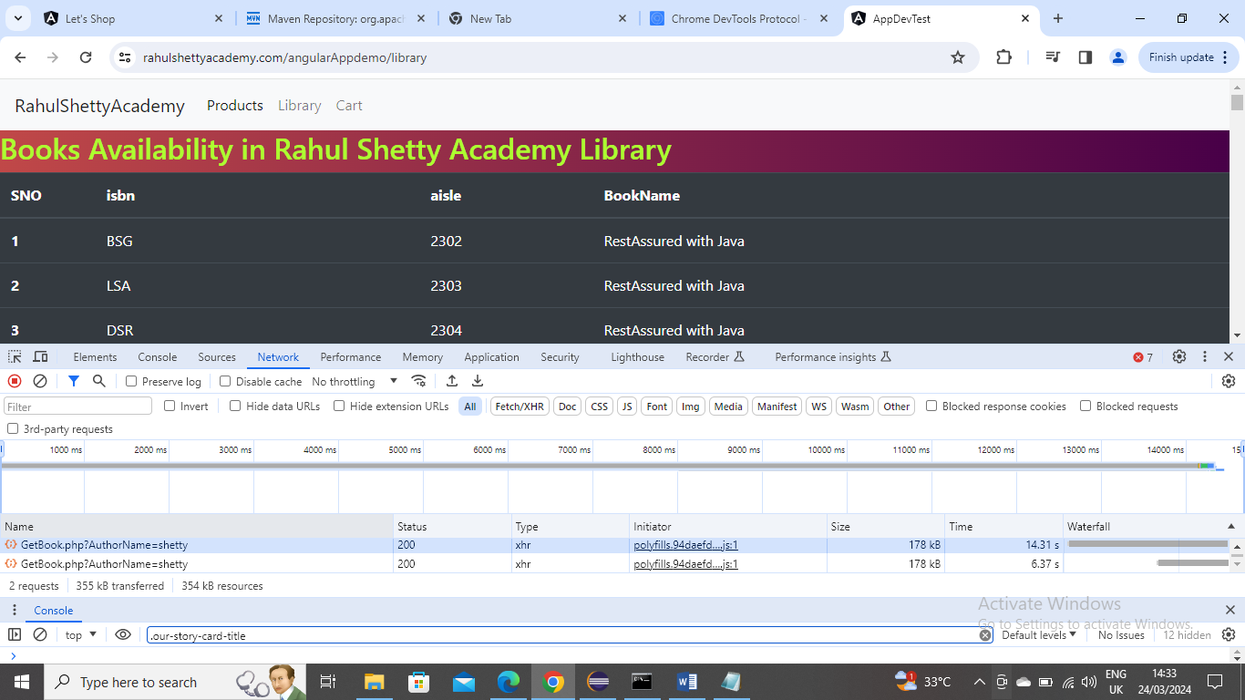

Now check the records and try to get the author name only 1 record is present

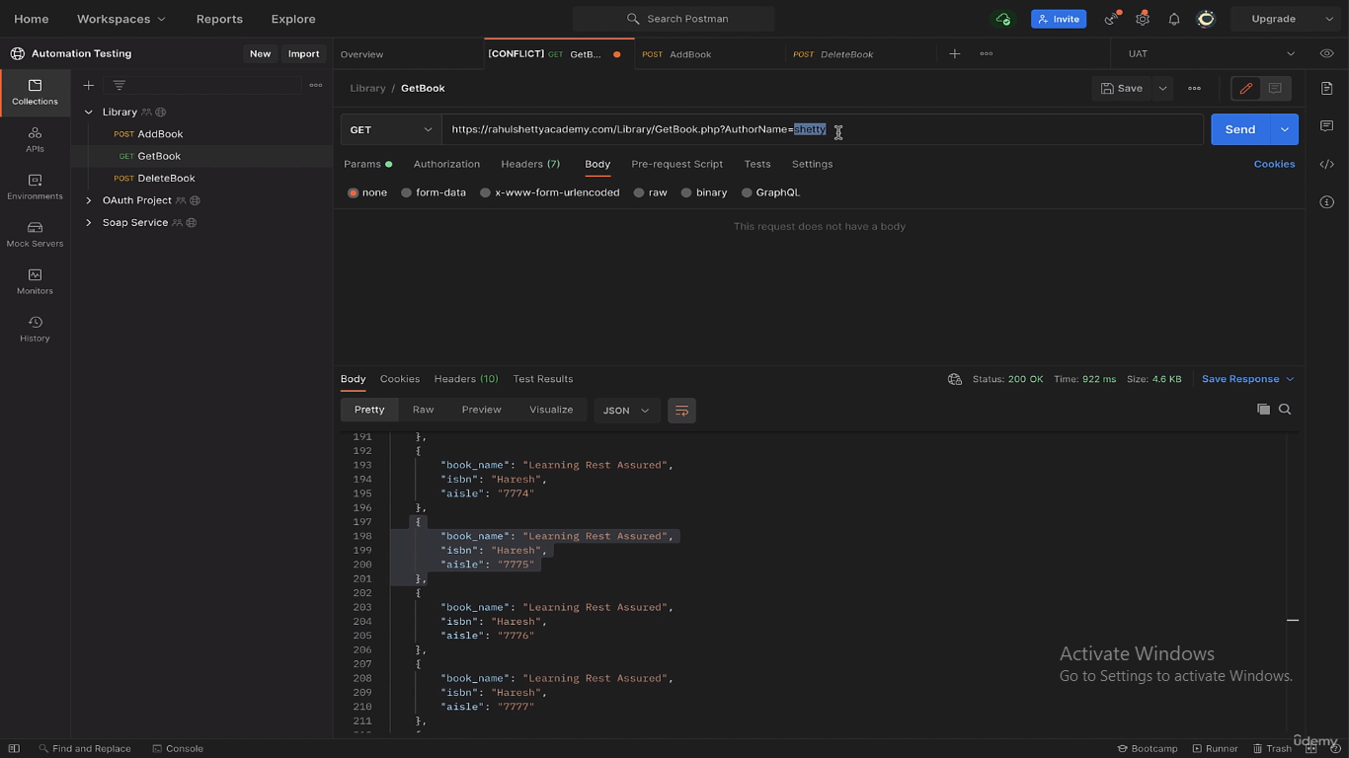

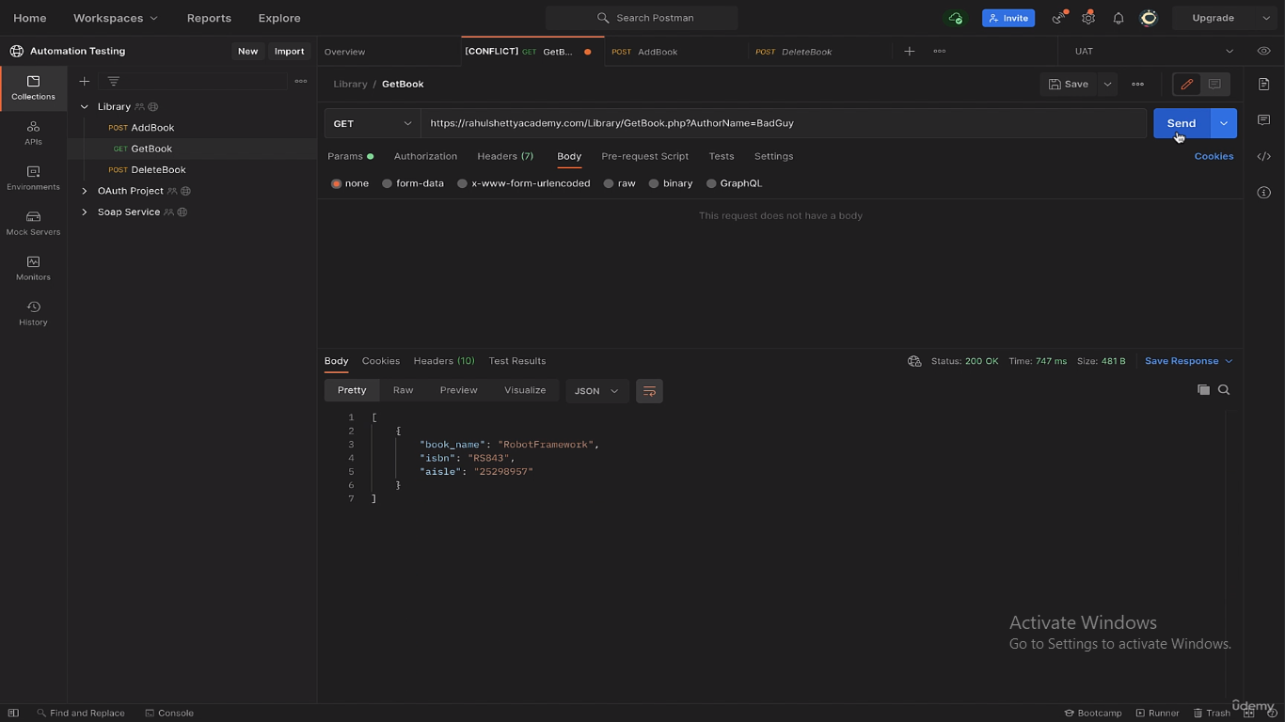

Below is the code

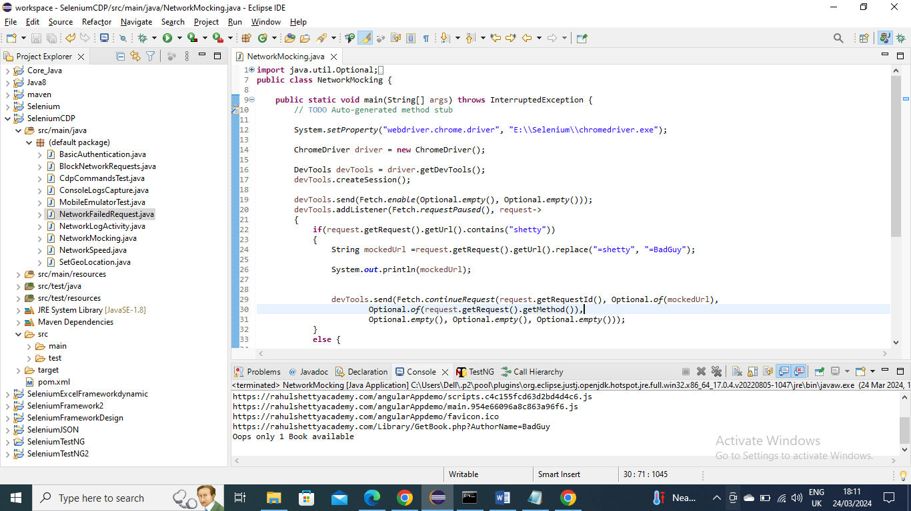

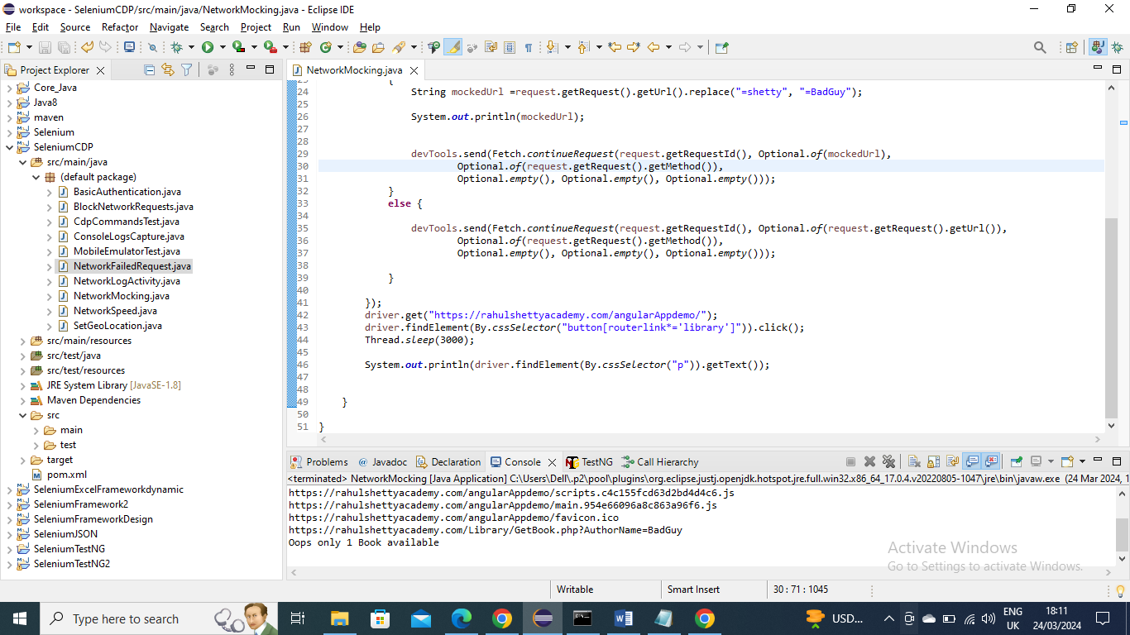

---------------------------------------

Below is an example where you are failing the Request wantedly

For example sometimes due to server busy or loading in real time if you service provider will end the request and gives something custom message like “issue from our end please come after some time” s

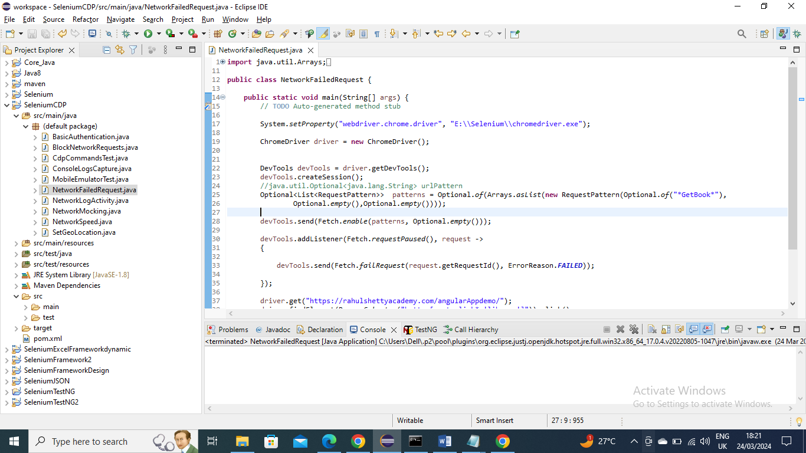

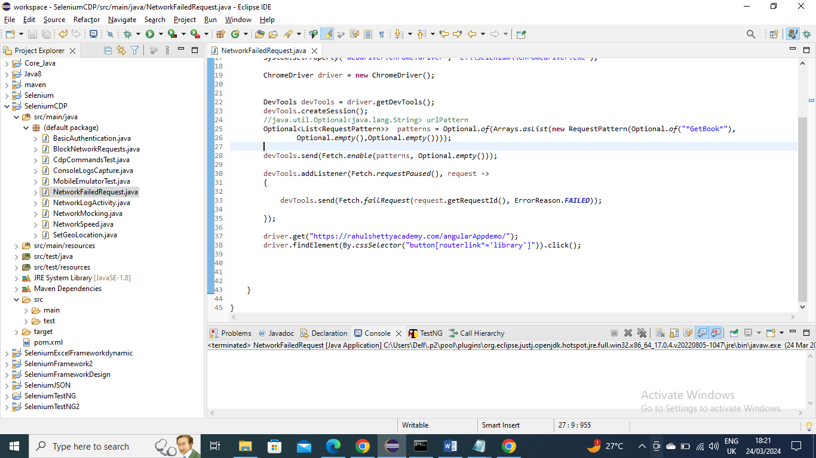

--------------------------------------

Below is an example where you want to Block the unwanted Network Request calls. For example a site you are trying to select and item and add to art testing which is functional but in that site if you have some images that takes time to load. Since we are doing functional testing we don’t need the images so we can block them using chrome dev tools

Below is the code

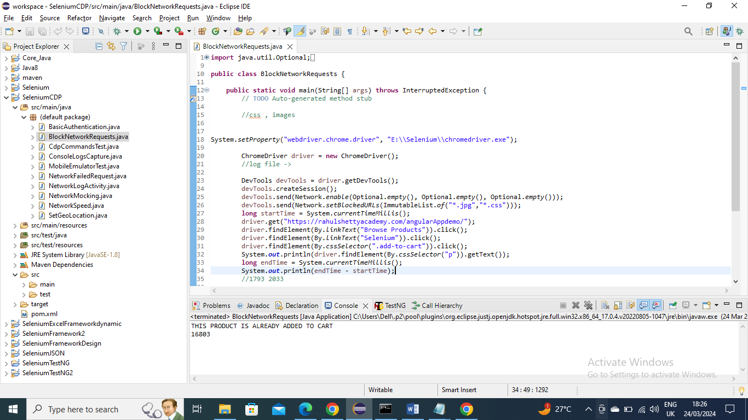

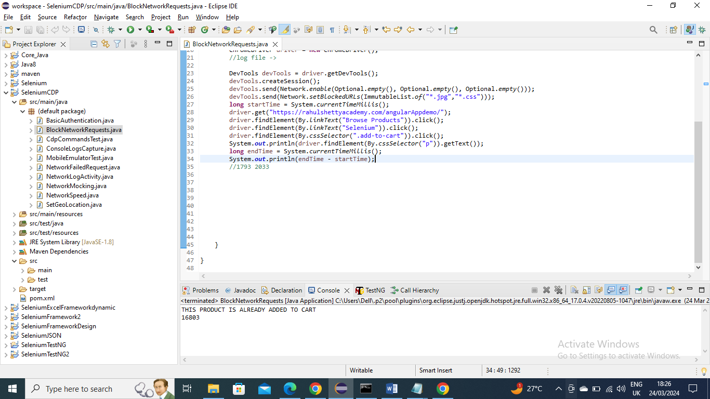

Before Blocking

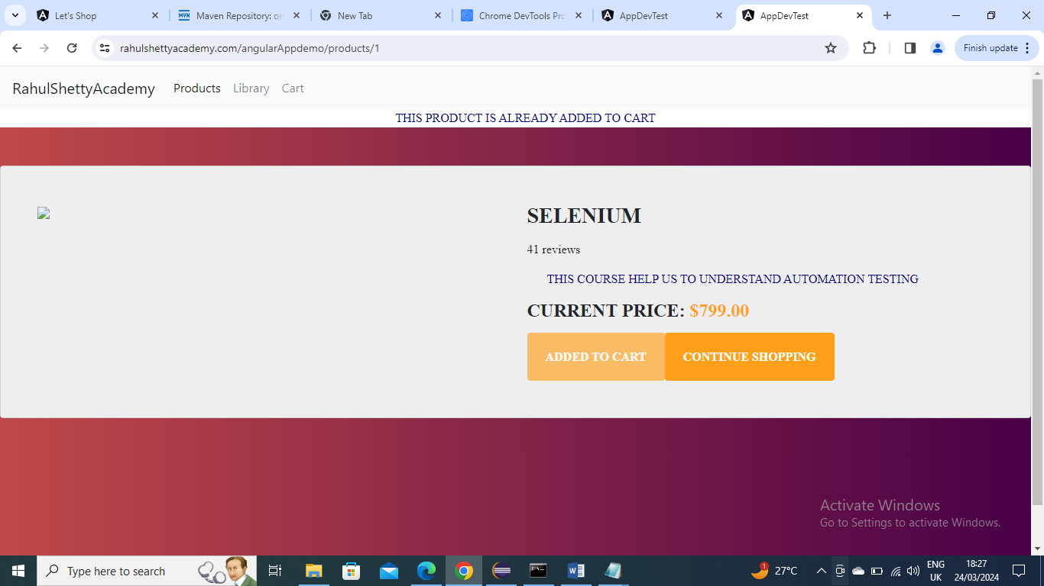

After program run which blocks

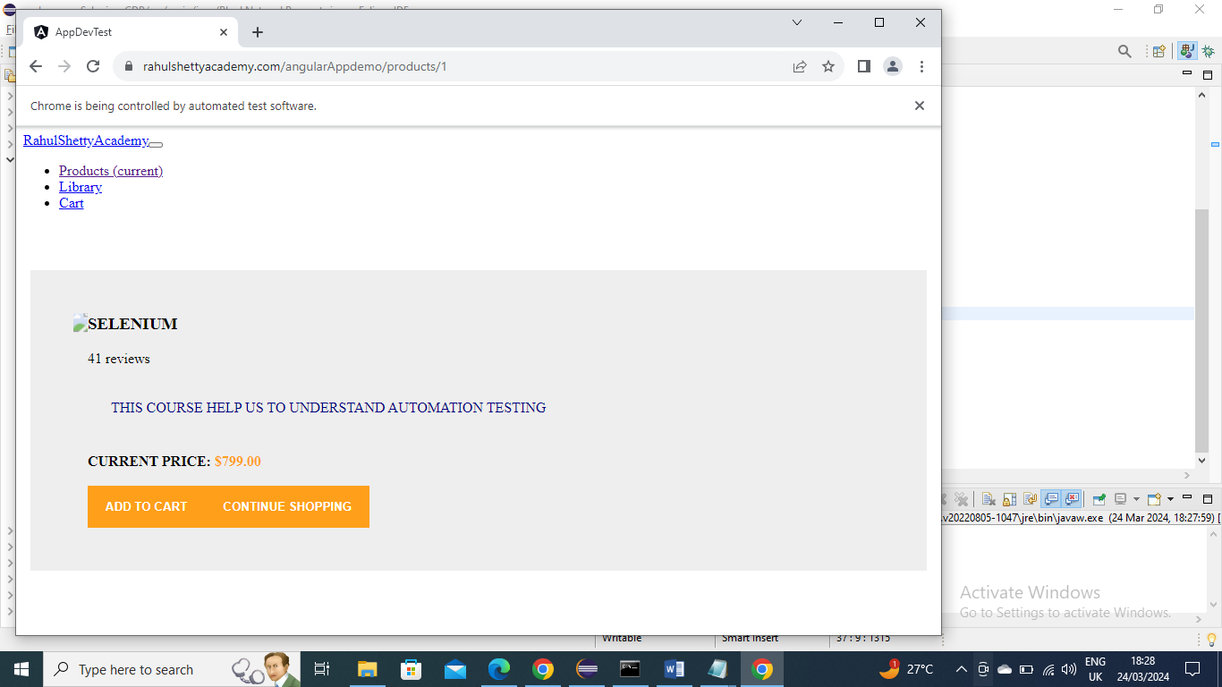

-------------------------------------

Below is an example where any certain site might run quicker at night time when less users are using it and slow at day time when many users are using it.

To emulated peak time and see if we are getting any errors for site (URL) loading

In below we are slowly the speed and if there is any issue we are getting the status and timestamp

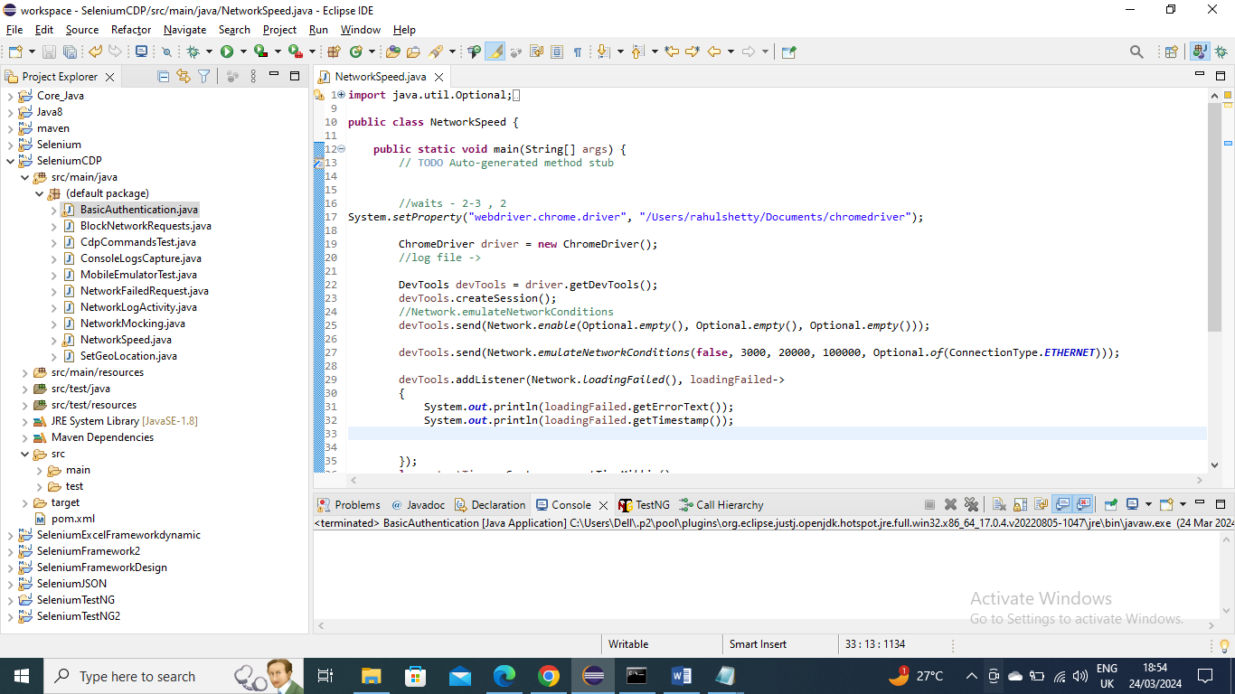

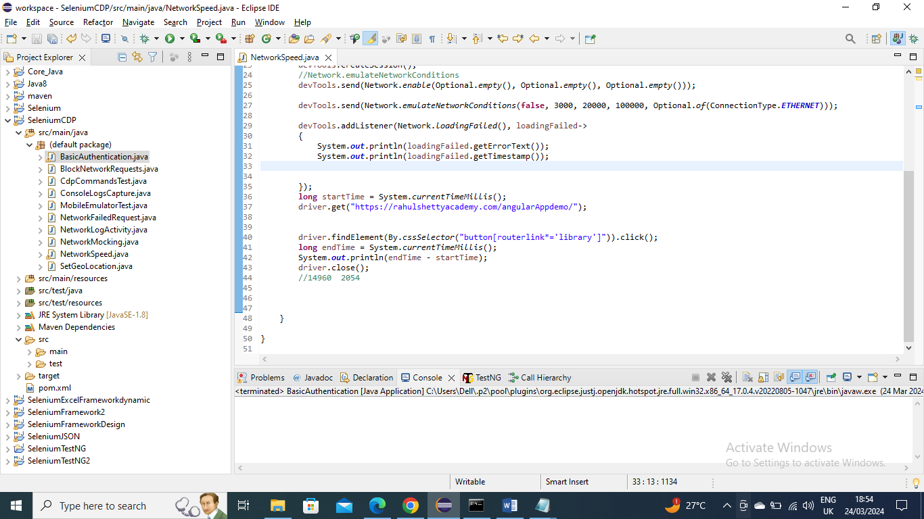

To get error message for example you can disconnect internet and run program to see status message

-------------------------------

Below is an example for Basic authentication where sometime Google chrome browser might ask login credentials

For example for below site it asks credentials username as “foo” and password as “bar” and once you give it opens the site

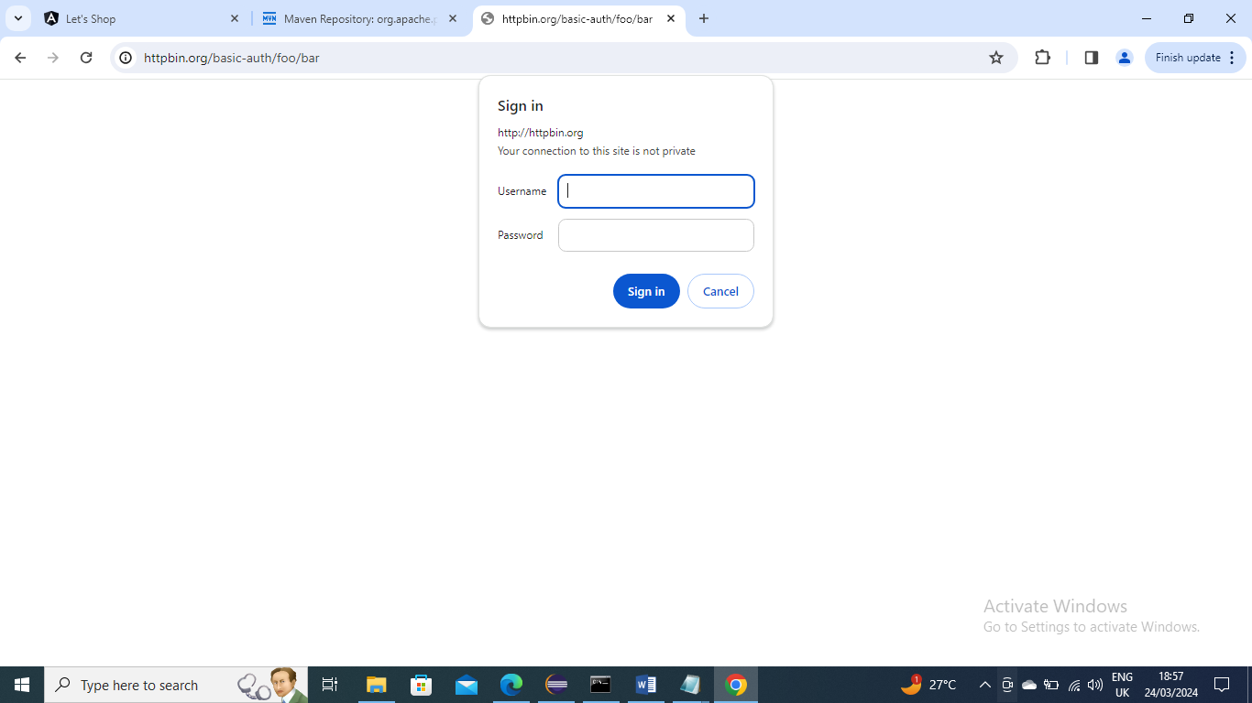

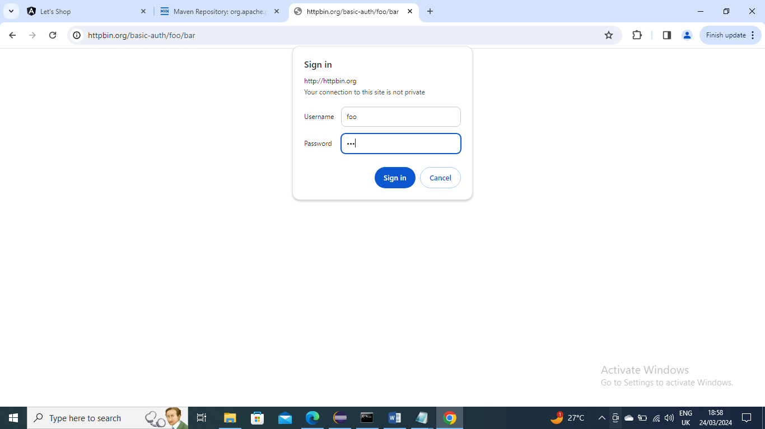

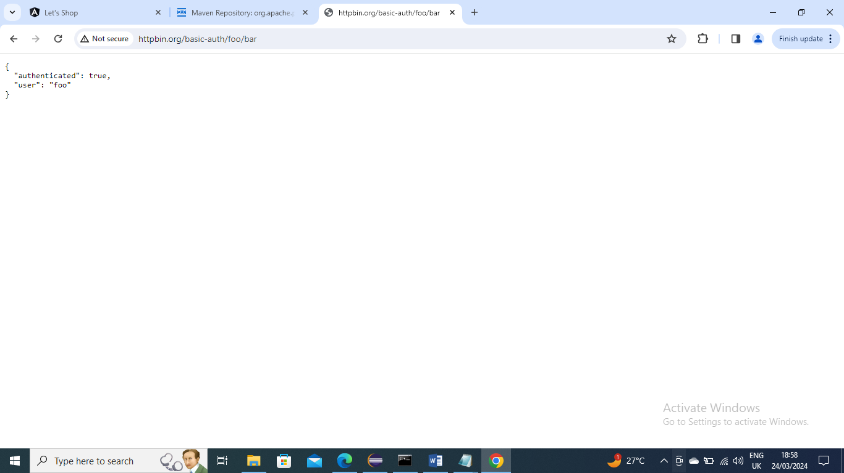

Below is the code for giving credentials for browser automatically

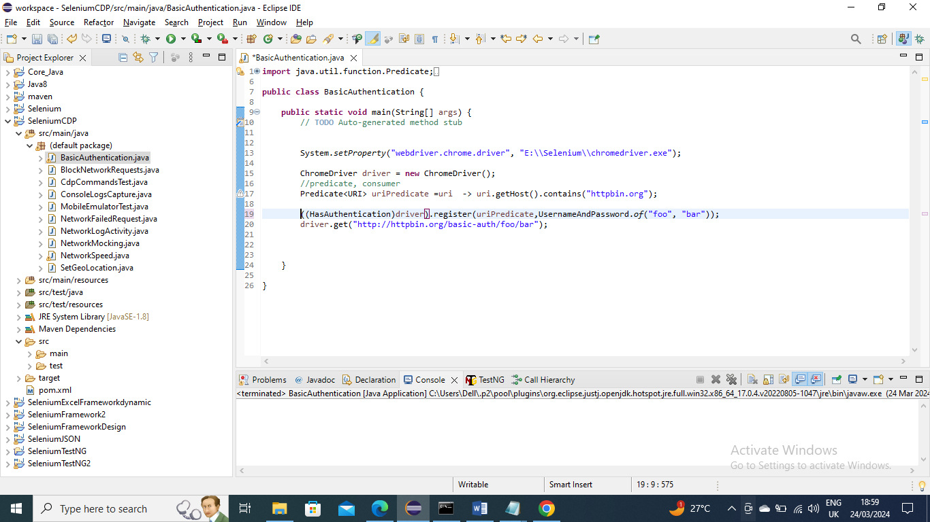

After running the code the credentials are giving by Selenium and site is opened

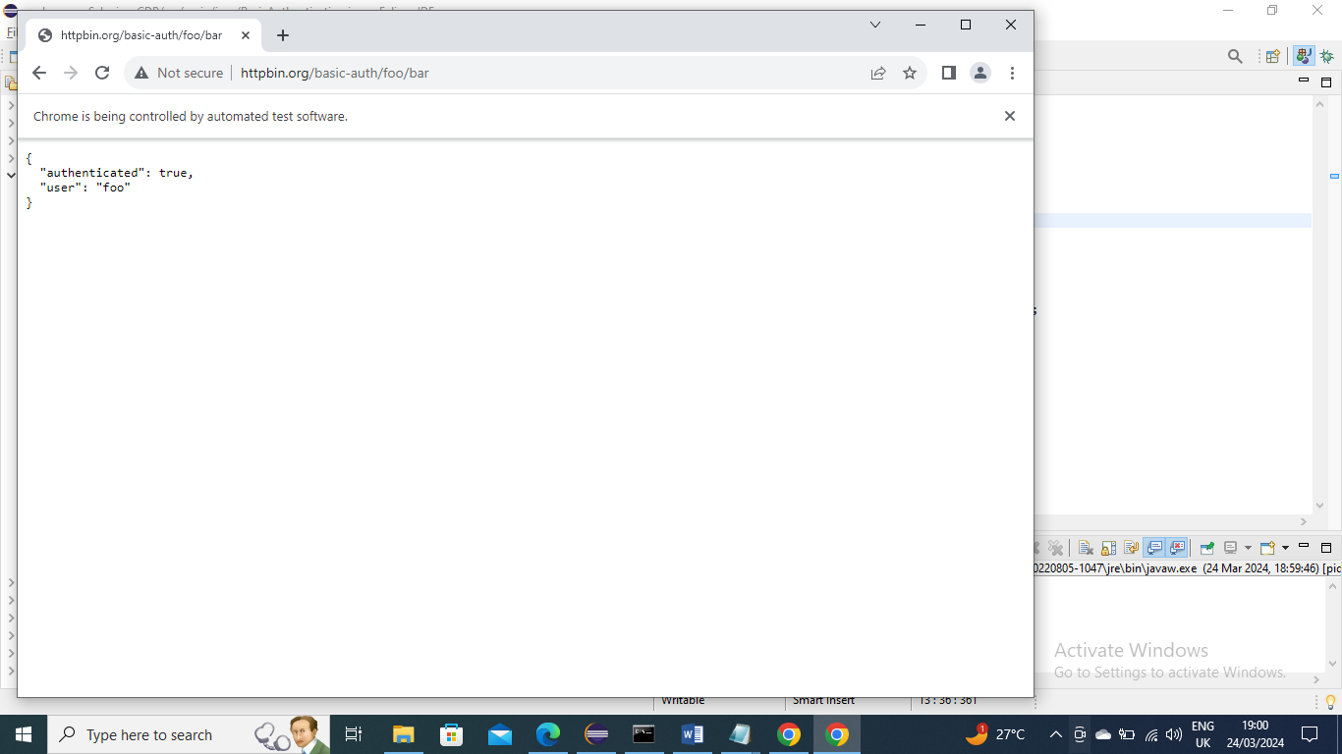

-----------------------------

Below is an example to log the javascript errors/success or anything from console of chrome to Selenium program

Below is the error of Javascript

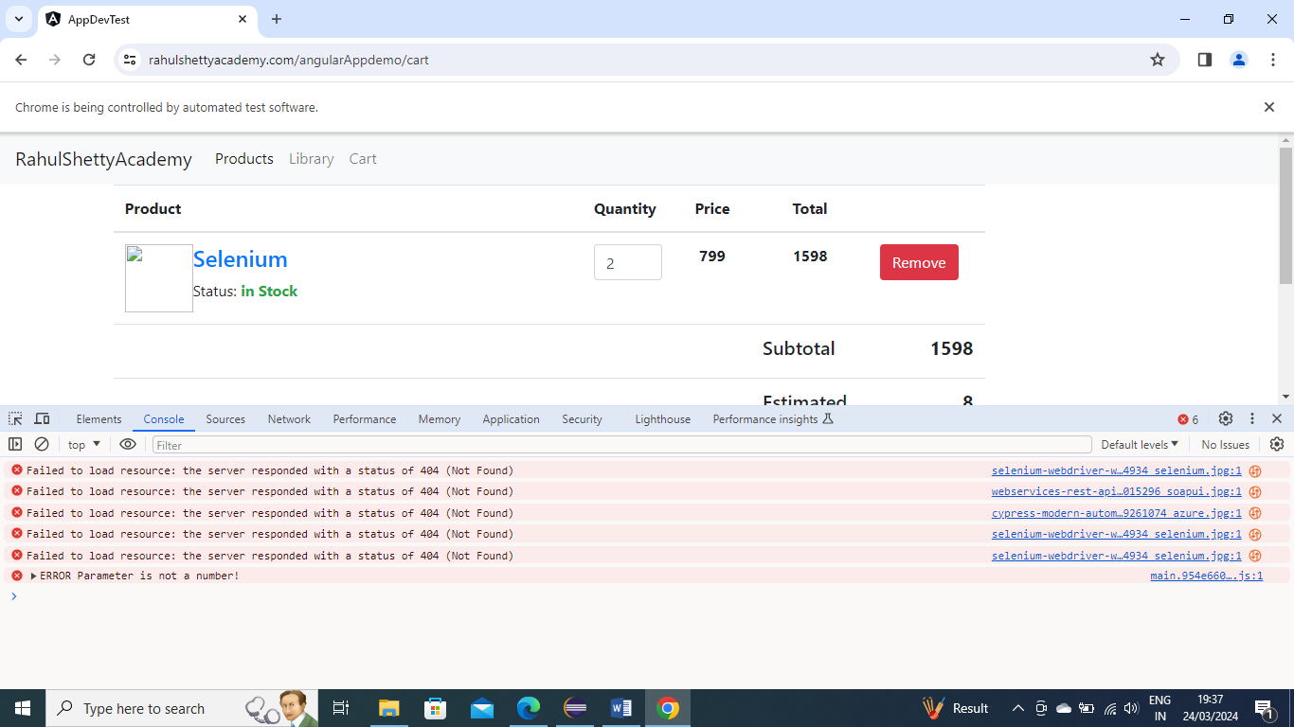

Now we will try to access/get it into our program

Below is the code

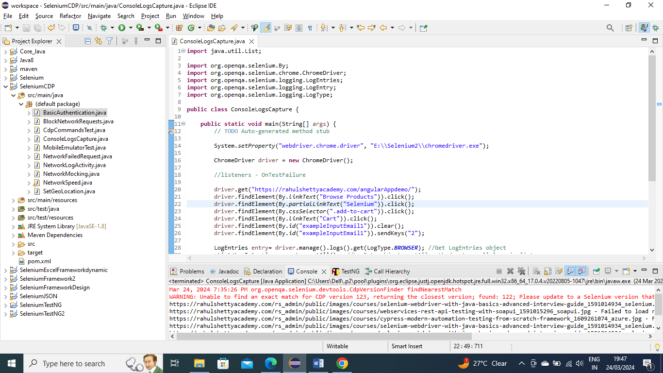

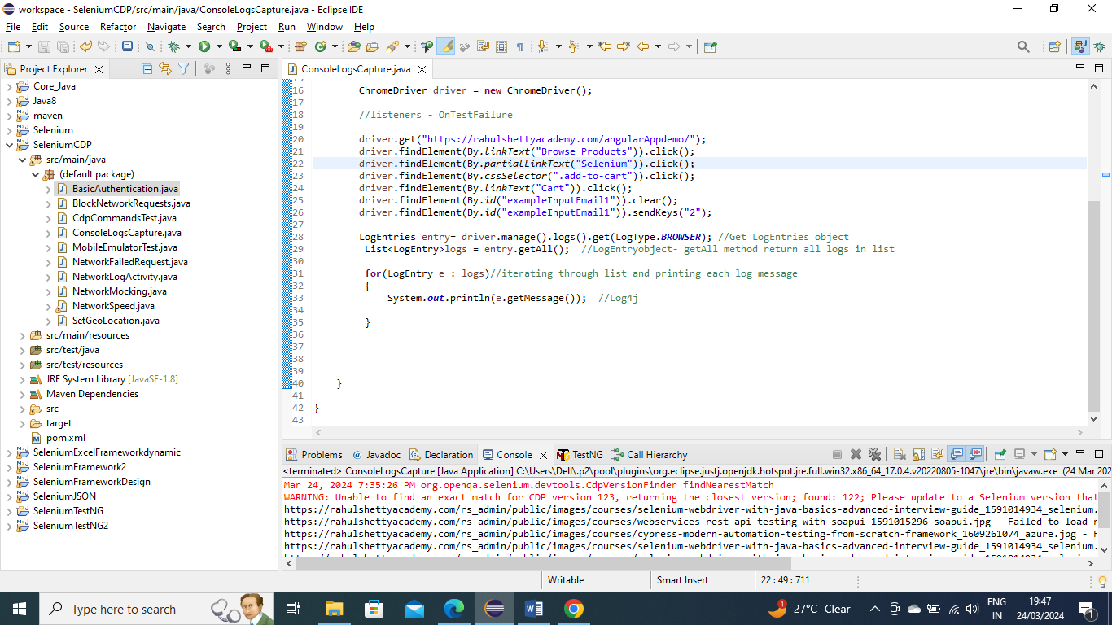

Now after the program is run you can see we go into our program and did a system.out.println to show from our program in general you can use it somewhere further as well

